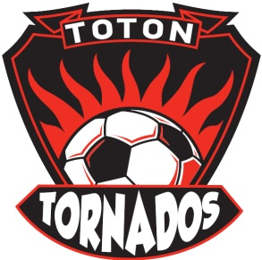
Toton Tornados FC

Complaints Procedure

In the event that any member of the Club feels that he or she has suffered discrimination in any way or that the Club’s Policies, Rules or Codes of Conduct have been broken, they should follow the procedures here.

1. They should report the matter to the Club Secretary or the Club Welfare Officer.

The report should include:
• Details of what, when and where the occurrence took place;
• Any witness statement and names;
• Names of any others who have been treated in a similar way;
• Details of any former complaints made about the incident, date, when and to whom made;
• A preference for a solution to the incident.

2. The Club’s Committee will sit for any hearings that are requested.

3. The Club’s Committee will have the power to:
• Warn as to future conduct;
- Suspend from membership;
- Remove from membership any person found to have broken the Club’s Policies or Codes of Conduct.

